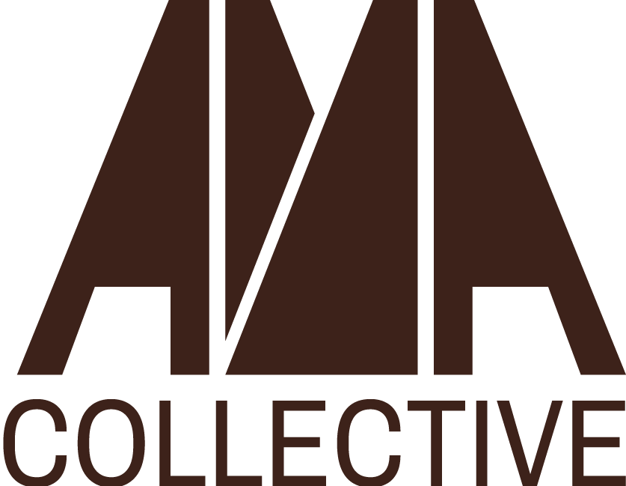 | NOW ACCEPTING APPLICATIONS  Social Media &  Communications Intern  Fall 2026 · Remote · Stipend
STIPEND  $1,500 |  | HOURS  20-22 hrs / month | TERM  Aug 24 – Dec 4, 2026

ABOUT THE OPPORTUNITY
The AMA Collective is a DC-based nonprofit advancing African and African diaspora cultural heritage through humanities education, digital innovation, and community programming. We are in the early stages of building this initiative and we want emerging creatives and communicators to grow with us. As an early member of our team, you will have the opportunity to learn about nonprofit operations, development strategy, financial management, and programming. We value the professional development of all our team members and envision this role for someone who is eager to expand outside of their comfort zone.
Reporting to the Executive Director, the Social Media & Communications Intern shapes and curates AMA’s digital footprint on major platforms, such as Instagram, Facebook, LinkedIn, TikTok, etc. You will create meaningful and artistic content to drive and increase awareness of our programming, mission, and fundraising activities. The role also allows for contribution to our digital magazine, through written work, photography, graphic design, or editing. Where applicable, you will offer your creative input and join us as we experiment with the intersections of digitality, oral histories, and visual art.

RESPONSIBILITIES  - Weekly Instagram posts, reels, and short-form video content  - Draft and send email newsletters to our listserv  - Set up and manage new social media accounts as needed  - Produce and interpret monthly analytics reports  - Update and maintain the AMA website  - Contribute writing and editing to our digital magazine and creative programming | WHO WE'RE LOOKING FOR  - Sophomore or junior level student  - Passionate about art, humanities, and the African diaspora  - Some experience developing social media campaigns  - Self-starter and collaborative team player  - Eligible to receive academic credit (preferred)  - Remote · Reports to Executive Director  - French or Spanish language skills a plus

HOW TO APPLY
Send your resume, 1-page cover letter, and portfolio or social media handle to: info@amacollective.org.
Use the subject line: Social Media Internship [Your Name].
Application deadline: August 3, 2026

The AMA Collective · info@amacollective.org · www.amacollective.org

